<https://www.proprofs.com/training/course/?title=copy-of-powerpoint-online-exam-test-2018>

https://drive.google.com/drive/folders/0B0fCOrYneVQ0SEoyRkNvR3dUNU0

**Skill Test**

***Time Limit 60 minutes.***

Note: Manage your time carefully.

Instructions:

* Start by saving this document using your name using the Save As option.
* You can work on the same document after you have changed the name of the document.
* Do not forget to save.

1. What do you understand by brand? Explain in 100-200 words.

**Brand has different meaning according to the various definition given by Marketing Economist, I believe that “Brand is the tag given to a product or services to recognize the maker and marketer of the specific product or services”. Brand refers to the company who establishes the business and takes it forward through marketing. In today’s competitive market there are various brands that are available International as well as National brand along-side a locally available brand can also be observed. Branding of product or services is required to showcase the products digitally so that the consumer can recognize the Products and services and varying in its content and marketing selects it.**

1. Given that you have gone through the website [www.zizira.com](http://www.zizira.com) and our social platforms, your answer to the below question should align to the Zizira brand.

Caption any **one** of the following images for a post on Facebook, Instagram and Twitter remembering that all platforms require different treatment; using the right description and hashtags (#) that will get people to engage with likes, shares, and comments. (Word limit 100-200)



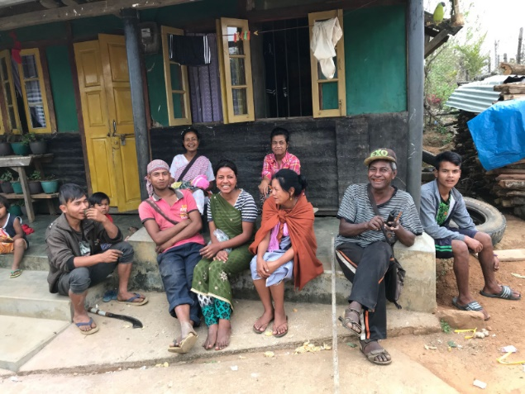

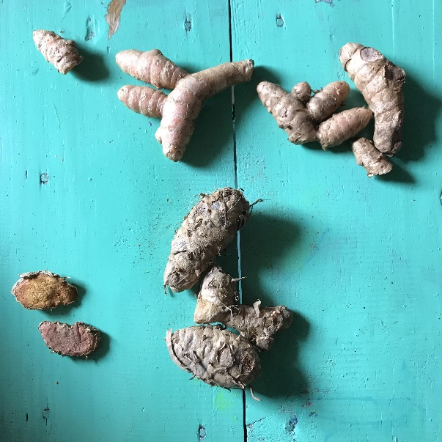

“What we see and read is what we eat!”

Ginger is known for its usage as food product, but Did you know about its medicinal usage? It may look tiny and out of shape, but its content makes it best for living a healthy and tuned life.

Ginger helps in dietary control as well as an ancient medicinal product. At zizira, it is used as a herbal content to make various healthy products, like tea, dietary products and herbal medicinal content. For detail product visit [www.zizira.com](http://www.zizira.com).

#ziziraproducts #Amazon #zizira

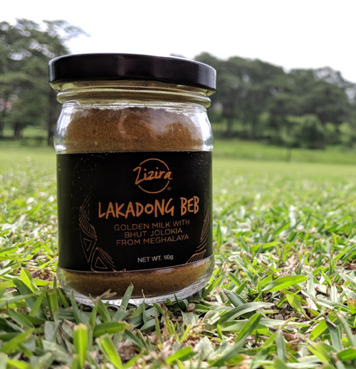



1. From your observation, of any of your favorite brand, what determines its success? Explain in 100 - 200 words.

“What we see is what we purchase!”

The success of any brand depends on its marketing content. Consumers today prefer purchasing products which are healthy and hygienic with nutritional value. Success comes along only when the products or services advertise are of great value and can captivate the minds of the consumers to think about the value of the product.

It is important to caption the products such that it is unique and can attract consumers. The ads campaign should promote the different values of the products showcased along with its nutritional value and production.

The consumers today are healthy conscious and monetary conscious as well. The product would be a success only if the health and money go together. Products should cover the monetary requirement of every individual. Consumer would not be willing to purchase any product if their branding and campaign are not attractive.

It is important to let the consumer know about the production process as well as the nutritional value of a product so that consumers can analysis their requirement. A product becomes a success when market can be retargeted many times with the branding.

1. What is the market trend that you see in India? What will keep a company strong and resilient from competition? Explain in 100-200 words.

In India, Markets vary from every city to city. It is important to know who the targeted audience is and what they are looking for. A company can be strong and resilient only if the marketing of their products can compete with other brands. For success, the company has to categorize its targeted audience and brand their product such that every audience can relate to it. Brand products such that what they see is what they get from the purchase.

Market trend is dynamic in India. Online discount and offers are required to attract audience to check the products. Audiences who are customers should be retargeted as through their reviews other audiences can be targeted.

Consumers satisfaction is the need of today market strategy in order to achieve a successful rate.

1. Write a script for a 1-minute video on ‘how to use/prepare Ing Makhir Fit Tea’. Product description provide: <https://www.zizira.com/products/ing-makhir-fit-tea-meghalaya>

Are you gaining weight, or desiring to fit into your favorite dress?

Life is always stressful and especially when you have less time to give to yourself.

Then here is a solution to your stressed mind. A nutritional, healthy and herbal Tea to keep you fit and glowing.

Ing Makhir Fit Tea is produced such that it enables you from gaining weight and keeps you fit for your daily work. It has herbal content which promotes its nutritional value and speeds up your metabolism allowing you to burn down fats and give you a slim glowing look as well as energizes you for everyday work.

For best result consume it Daily.

**All the best**